e ISO/IEC JTC 1/SC 29/WG 04 N 0113

**ISO/IEC JTC 1/SC 29/WG 04  
MPEG Video Coding   
Convenorship: CN**

**Document type:** Output Document

**Title:** Common Test Conditions for MPEG Immersive Video

**Status:** Approved

**Date of document:** 2021-07-23

**Source:** ISO/IEC JTC 1/SC 29/WG 04

# Expected action: None

# Action due date: None

# No. of pages: 21

**Email of Convenor:** yul@zju.edu.cn

**Committee URL:** <https://isotc.iso.org/livelink/livelink/open/jtc1sc29wg4>

**INTERNATIONAL ORGANIZATION FOR STANDARDIZATION**

**ORGANISATION INTERNATIONALE DE NORMALISATION**

**ISO/IEC JTC 1/SC 29/WG 04 MPEG VIDEO CODING**

**ISO/IEC JTC 1/SC 29/WG 04 N 0113**

**July 2021, Online**

|  |  |
| --- | --- |
| **Title** | **Common Test Conditions for MPEG Immersive Video** |
| **Source** | **WG 04 MPEG Video Coding** |
| **Status** | **Approved** |
| **Serial Number** | **20597** |
| **Authors** | **Joel Jung (Tencent), Bart Kroon (Philips)** |

1. **Introduction**

Common test conditions are desirable to conduct coding experiments in a well-defined environment and ease the comparison of the outcome of experiments. This document specifies the common test conditions for ISO/IEC 23090-12 MPEG Immersive Video (MIV) related activities. The common test conditions are defined to evaluate the coding efficiency, subjective quality, pixel rate and user experience of immersive video solutions. The technical approach is following these steps:

1. Compress test content,
2. Synthesize intermediate views from decoded views and metadata (when available),
3. Render viewports of real/virtual pose traces with a limited or a wider movement,
4. Evaluate coding efficiency and parallax effect, considering both decoded views and synthesized views.

The bitstream is viewer-independent, meaning that neither the position nor the orientation of the viewer is considered when compressing the test content. The range of supported possible viewer positions is constrained and known.

Three anchors are used that are based on the latest Test Model for Immersive Video(TMIV) in combination with the VVenC encoder. The first one, the *MIV anchor*, is a configuration of TMIV + VVenC, encoding some source views completely while taking only patches of others. The second one, the *MIV view anchor*, is a configuration of TMIV + VVenC, restricted to encode an automatically determined subset of source views completely, not subdividing views into patches. The third one, the *MIV decoder-side depth-estimating* anchor, is a configuration of TMIV + VVenC + IVDE, restricted to encoding an automatically-determined subset of source views without geometry information, and applying depth estimation in between decoding and rendering.

In addition, there is the *best reference*, which is the best-known configuration of TMIV to render synthesized views using the full source material and without coding.

1. **Test material**

This section lists the test material that is used by the common test conditions. Annex A provides detailed descriptions of the sequences. The configuration files are attached to the TMIV reference software TM1].

All test material is available from the following location on the MPEG content server:

/MPEG-I/Part12-ImmersiveVideo/ctc_content/

The test material is provided as a set of raw sequences, one per view and component (texture or depth). Texture and depth maps sequences characteristics are reported in Annex A. The sequences have a common format as defined in the Call for MPEG-I Visual Test Materials [CFTM] determining texture and depth representations, filenames, and metadata. The views are numbered according to the ordering of the metadata files, counting from zero. Video data is named as follows:

v0_texture_4096x2048_yuv420p10le.yuv

v0_depth_4096x2048_yuv420p16le.yuv

using view 0 of ClassroomVideo as an example. The general format is:

**v**ViewNumber**_**Component**_**Width**x**Height**_**VideoFormat**.yuv**

Table 1 provides the list of sequences. The test material is organized into two categories: class CG for computer-generated content, and class NC for natural content with estimated depth. There are mandatory sequences, which results are required for non-informative proposals, and optional sequences. Optional sequences are challenging content, deliberately difficult to handle. They are not meant for evaluation or promotion of the test model. The split between mandatory and optional sequences is given in Section 3, as it depends on the anchor.

*Table 1: List of sequences*

|  |  |  |  |  |  |  |  |
| --- | --- | --- | --- | --- | --- | --- | --- |
| CG - A | ClassroomVideo |  | CG - O | Fan |  | NC - D | Painter |
| CG - B | Museum |  | CG - J | Kitchen |  | NC - E | Frog |
| NC - P | Carpark |  | CG - R | Group |  | NC - U | Street |
| CG - N | Chess |  | NC - L | Fencing |  | NC - T | Hall |
| CG - Q | ChessPieces |  | CG - I | Mirror |  |
| CG - C | Hijack |  | CG - G | Cadillac |  |

**Software tools**

The referenced tools are listed in Table 2, with source code location, documentation and release tag. Please consult the report on anchor generation for any updates.

*Table 2: List of used tools*

|  |  |  |  |
| --- | --- | --- | --- |
| Tool name |  | Location | Release |
| TMIV | [TM1] | <https://gitlab.com/mpeg-i-visual/tmiv> | v10.0 |
| VVenC |  | https://github.com/fraunhoferhhi/vvenc | v0.3.1.0 |
| VVdeC |  | https://github.com/fraunhoferhhi/vvdec | v1.0.1 |
| IV-PSNR | [IVPSNR] | <https://gitlab.com/mpeg-i-visual/ivpsnr> | v3.0 |
| IVDE | [IVDE] | <https://gitlab.com/mpeg-i-visual/ivde> | v4.1 |

* 1. ***VVenC***

The VVenC implementation of VVC is used for all anchors. The expert mode (vvencFFapp) based on VVC test model is used, with the random access “slow” configuration. The configuration file is attached to the TMIV software.

* 1. ***IV-PSNR***

The PSNR for Immersive Video (IV-PSNR) metric is a full-reference metric based on the PSNR. It includes two major changes: the pixel shift, that considers that edges of the objects in the synthesized view may be shifted due to rounding errors, and the global color shift, that considers that different input views may have various color characteristics. IV-PSNR software produces, in addition to the IV-PSNR score, the WS-PSNR score for both perspective and omni-directional contents.

* 1. ***IVDE***

Immersive Video Depth Estimation (IVDE) is a depth estimation method that can be used to create geometry data for a 6DoF/3DoF+ scene representation from views acquired by multiple perspective or omnidirectional cameras. Depth is estimated for segments instead of individual pixels, and thus the size of segments can be used to control the trade-off between the quality of depth maps and the processing time. Larger segments can be used to attain fast depth estimation, or finer segments can be used to attain higher quality.

IVDE further includes a feature extractor, used with the Decoder-Side-Depth-Estimating anchor, to produce a list of blocks to be skipped by IVDE.

1. **Anchor definition**

Three anchors are considered to encode the multi-view sequences:

* **MIV anchor**: coding with TMIV + VVenC, packing some source views completely while taking only patches of others,
* **MIV view anchor**: coding with TMIV + VVenC, packing a subset of source views completely, not subdividing views into patches.
* **MIV decoder-side depth-estimating anchor**: encoding with TMIV + VVenC, packing a subset of source views completely but without their geometry information, followed by decoding, depth estimation and rendering with TMIV + IVDE.

In addition, there is a non-anchor reference condition: **best reference**: directly render from all source views with TMIV and without coding.

An algorithmic description of TMIV is provided in [TMIV]. VVenC is configured to encode each video sub-bitstream using the VVC random access profile. All configuration parameters for each of the anchors is provided by this document and its attachments.

CTC-specific configuration files and detailed run instructions are provided with the reference software [TM1]. CTC-specific IVDE configuration files for IVDE are provided with IVDE software.

* 1. ***Coding of the anchor views***

A configuration “17fr” with 17 frames only is used to compare the anchors against each other. The configuration “97fr”, with 97 frames is mandatory when proposing an improvement of the MIV anchor and is used (optionally) when proposing an improvement of the MIV view or MIV DSDE anchor. The start frames for each sequence are reflected in Table 3. Specific details for each anchor are given in the following sub-sections.

*Table 3:* *Start frames for each sequence.*

|  |  |  |
| --- | --- | --- |
| Id | Sequence | Start frame |
| CG - A | ClassroomVideo | 23 |
| CG - B | Museum | 100 |
| CG - C | Hijack | 0 |
| CG - N | Chess | 60 |
| CG - J | Kitchen | 0 |
| NC - D | Painter | 40 |
| NC - E | Frog | 135 |
| NC - L | Fencing | 30 |
| NC - P | Carpark | 115 |
| NC - U | Street | 145 |
| NC - T | Hall | 0 |
| CG - R | Group | 0 |
| CG - O | Fan | 0 |
| CG - Q | ChessPieces | 60 |
| CG - I | Mirror | 0 |
| CG - G | Cadillac | 0 |

* 1. ***Coding for the MIV anchor***

For each video sequence, two sets of QP points are considered, medium and low, corresponding respectively to QP1, QP2, QP3, QP4, and QP2, QP3, QP4, QP5. The set of QPs for the texture is sequence dependent, to target the 5 to 50 Mbps bitrate range, as defined in Table 4. To each texture QP corresponds one single geometry QP. The mapping from texture QP (*q*) to geometry QP (*q’*) is the same for all sequences, and is given by:

$q^{'}=\max_{ }\left(1,\left[-14.2+0.8q\right]\right)$ (1)

whereby $\left[∙\right]$ indicates the rounding to nearest integer operation.

The anchor encodes all source views with geometry input bit depth as reported in tables of Annex A (16 bits for all sequences except Kitchen). The anchor bitstreams include decoded picture hashes for automatic consistency checking.

The mandatory sequences are A, B, O, J, D, E, P, N, R. All other sequence from Table 1 are optional.

*Table 4: MIV anchor QPs used to encode texture attribute video sub bitstreams*

|  |  |  |  |  |  |
| --- | --- | --- | --- | --- | --- |
| **Sequence Id** | **QP1** | **QP2** | **QP3** | **QP4** | **QP5** |
| CG – A | 26 | 28 | 33 | 41 | 50 |
| CG – B | 30 | 38 | 44 | 48 | 51 |
| CG – C | 16 | 21 | 28 | 38 | 49 |
| CG – J | 17 | 24 | 29 | 35 | 41 |
| CG – N | 18 | 25 | 31 | 37 | 45 |
| NC – D | 22 | 29 | 38 | 45 | 51 |
| NC – E | 28 | 32 | 37 | 42 | 46 |
| NC – P | 22 | 26 | 33 | 40 | 47 |
| NC – L | 22 | 26 | 33 | 42 | 51 |
| NC – T | 15 | 23 | 31 | 40 | 47 |
| NC – U | 20 | 23 | 28 | 34 | 41 |
| CG – O | 30 | 35 | 41 | 46 | 51 |
| CG – R | 22 | 28 | 34 | 39 | 46 |
| CG – Q | 18 | 24 | 31 | 40 | 50 |
| CG – I | 25 | 31 | 37 | 44 | 51 |
| CG – G | 28 | 31 | 37 | 44 | 51 |

Coding for the MIV anchor has the following steps:

1. Encode the MIV bitstream using the TMIV encoder.
2. Encode the resulting attribute video data using the VVenC encoder.
3. Multiplex the bitstreams using the TMIV multiplexer.
4. Decode and render the MIV bitstream using the TMIV decoder.
   1. ***Coding for the MIV view anchor***

The coding of the MIV view anchor is like the MIV anchor. The encoder parameters are the same except:

* maxBasicViewFraction = 1.0
* outputAdditionalViews = false

The mandatory sequences are A, B, O, J, D, E, P, N, R. All other sequence from Table 1 are optional.

The texture QPs are defined in Table 5 and the geometry QPs follow from equation (1).

*Table 5: MIV view anchor QPs used to encode texture attribute video sub bitstreams*

|  |  |  |  |  |  |
| --- | --- | --- | --- | --- | --- |
| **Sequence Id** | **QP1** | **QP2** | **QP3** | **QP4** | **QP5** |
| CG – A | 27 | 29 | 33 | 41 | 49 |
| CG – B | 33 | 41 | 46 | 49 | 51 |
| CG – C | 14 | 17 | 22 | 29 | 35 |
| CG – J | 21 | 27 | 31 | 36 | 41 |
| CG – N | 17 | 24 | 28 | 34 | 40 |
| NC – D | 22 | 29 | 37 | 42 | 47 |
| NC – E | 30 | 33 | 36 | 43 | 46 |
| NC – P | 22 | 25 | 32 | 38 | 43 |
| NC – L | 22 | 25 | 31 | 38 | 45 |
| NC – T | 15 | 22 | 29 | 36 | 44 |
| NC – U | 21 | 24 | 28 | 34 | 40 |
| CG – O | 31 | 34 | 41 | 46 | 51 |
| CG – R | 23 | 28 | 33 | 37 | 42 |
| CG – Q | 17 | 22 | 28 | 36 | 43 |
| CG – I | 22 | 28 | 34 | 41 | 47 |
| CG – G | 28 | 31 | 37 | 44 | 51 |

Coding for the MIV view anchor has the following steps:

1. Encode the MIV bitstream using the TMIV encoder.
2. Encode the resulting attribute video data using the VVenC encoder.
3. Multiplex the bitstreams using the TMIV multiplexer.
4. Decode and render the MIV bitstream using the TMIV decoder.
   1. ***Coding for the MIV decoder-side depth-estimating anchor***

The coding of the MIV decoder-side depth-estimating anchor is like the MIV view anchor. The encoder parameters are the same except:

* dynamicDepthRange = false,
* haveGeometryVideo = false,
* geometryScaleEnabledFlag = false,
* maxAtlases = 4

The mandatory sequences are O, J, D, E, P, R. All other sequence from Table 1 are optional.

The texture QPs are defined in Table 6. Note that there is no geometry to encode, hence no depth QPs.

Table 6: MIV decoder-side depth-estimating anchor QPs used to encode texture attribute video sub bitstreams

|  |  |  |  |  |  |
| --- | --- | --- | --- | --- | --- |
| **Sequence Id** | **QP1** | **QP2** | **QP3** | **QP4** | **QP5** |
| CG - A | 29 | 31 | 36 | 43 | 50 |
| CG - B | 39 | 46 | 49 | 50 | 51 |
| CG - C | 18 | 21 | 26 | 31 | 35 |
| CG - J | 26 | 31 | 35 | 39 | 43 |
| CG - N | 23 | 28 | 32 | 37 | 42 |
| NC - D | 23 | 28 | 34 | 37 | 41 |
| NC - E | 29 | 31 | 34 | 39 | 44 |
| NC - P | 21 | 23 | 28 | 32 | 35 |
| NC - L | 21 | 24 | 26 | 29 | 34 |
| NC - T | 12 | 15 | 17 | 20 | 25 |
| NC - U | 21 | 23 | 25 | 30 | 35 |
| CG - O | 29 | 30 | 33 | 39 | 46 |
| CG - R | 28 | 32 | 36 | 40 | 46 |
| CG - Q | 22 | 27 | 33 | 39 | 45 |
| CG - I | 25 | 31 | 36 | 42 | 48 |
| CG – G | 26 | 31 | 37 | 42 | 48 |

Coding for the MIV decoder-side depth-estimating anchor has the following steps:

1. Encode the MIV bitstream using the TMIV encoder.
2. Encode the resulting attribute video data using the VVenC encoder.
3. Multiplex the bitstreams using the TMIV multiplexer.
4. Decode (but not render) the MIV bitstream using the TMIV decoder.
5. Extract features (information on which blocks to be skipped by IVDE) using the feature extractor.
6. Estimate depth maps for each view using IVDE.
7. Render using the TMIV renderer.

***Synthesis of intermediate views***

Both for objective and subjective testing, a range of frames of each sequence is synthesized at source positions. For the synthesis, all decoded atlases are used as input of the view synthesis algorithm.

Proposals are not required to code views corresponding to all anchor-coded views but are required to be able to reconstruct source views and generate viewports for any intermediate view position in the designated range for each test sequence. Each sequence definition includes a virtual view named “viewport” that defines the field of view and resolution of the viewports.

The format of each synthesized view is an omnidirectional image with equirectangular projection with the same angular resolution (pixels / degree) for ERP or semi-ERP test materials, and a linear perspective projection for linear perspective input content. The synthesis result is 10-bit YUV 4:2:0 format for subjective and objective evaluation. Inpainting of invalid pixels is used for both subjective and objective testing.

1. **Evaluation of proposals**

Objective and subjective results on mandatory sequences only are required for an adoption of a proposal. Additional results obtained on optional sequences can be provided as additional information.

Bitrate matching between the anchor and the proposal is encouraged to facilitate the objective and subjective comparison. The proponent is allowed to have a single QP change to better match the QP of the anchor.

* 1. ***Subjective quality evaluation***

For subjective viewing, each sequence is synthesized according to a set of pose traces. A pose trace specifies for each frame the position and orientation of the viewport to synthesize. Each pose trace is stored as a comma-separated table with position (X, Y, Z) and orientation (Yaw, Pitch, Roll) columns and exactly one row per frame of the sequence. The format of each synthesized view is an image with perspective projection with at most 2048 × 2048 pixels resolution, at most 90-degree field of view and 10-bit YUV 4:2:0 color format. The purpose is to mimic natural viewing on a head-mounted display while using offline tools and a 2D monitor.

Because of the large difference in visual comfort between a viewer that voluntarily initiates head motion versus a viewer watching the same viewport on a 2D monitor, pose traces have a small amount of motion. For each sequence there are three pose traces – named *X*p01, *X*p02 and *X*p03 – which are meant to represent a diversity of natural head movement compliant with the overall dimension of the capture rig. The pose traces are attached to the TMIV reference software [TM1]. The TMIV decoder is configured to extend the video to 300 frames by mirroring the 97-frame sequences. It is meaningful to define the pose traces according to the conditions of capture, and typically to define the related path within the volume of the camera rig. It is convenient to formulate this range as a volume in 3D space.

For adoption of a proposed method, the proponent must provide any pose trace of the proposed method, during a viewing session, and make it clear what the bitrate and pixel-rate differences with the anchor are.

The mp4 pose traces are 1920 x 1080 viewports converted from the YUV pose trace. The following command line shall be used to generate the mp4 pose traces:

ffmpeg \  
 -f rawvideo -pix_fmt yuv420p10le -s:v 1920x1080 -r ${rate} -i {input}.yuv \  
 -c:v libx264 -crf 10 -pix_fmt yuv420p {output}.mp4

whereby ${rate} is the frame rate in Hz, e.g. 25 or 30. It is recommended to use ffmpeg 4.2 or newer.

* 1. ***Objective evaluation***

A “synthesized view” corresponds to a source view that is reconstructed through synthesis (view interpolation) by the anchor using the decoded bitstream. All source views are synthesized for objective evaluation, and it is not considered if the source view is fully, partially or not at all present in the bitstream.

The proposal should be compared with the anchor coding results, by reporting the metrics using the reporting template provided in [ANCH]. This includes a tab per sequence, a summary sheet and an analysis sheet per metric. BD-rates and averages are automatically calculated to ensure consistent reporting.

For all test classes, the IV-PSNR software will be used to compute both the WS-PSNR and IV-PSNR based BD-rate values will be provided for synthesized source views. For perspective views WS-PSNR reduces to regular PSNR. The comparison of proposals with the anchors will be expressed in terms of BD rate computed on low- and medium bitrate rate-distortion curves.

The BD-rates for anchor and proponent are obtained from:

* The average over each source view and specified frames (Table 3) of the metric between the intermediate view synthesized from decoded atlases and the original/non-compressed source views,
* The total bitrate required to encode the views (including depths) for all frames.

For WS-PSNR and IV-PSNR the average is computed in mean square error (MSE) space.

Because TMIV makes use of floating-point operations, it is important to report the compiler and operating system that are used for evaluation. Preferred compilers are GCC 7 or newer and VC15 or newer. The TMIV software includes a manual with build instructions.

When the BD-rate computation returns a zero value, no average over all sequences will be calculated for this metric (instead “---” is printed). The reporting template includes rate-distortion curves for each metric to study and report the reason for the lack of overlap.

* 1. ***Pixel rate evaluation***

Objective evaluation criteria include pixel rate, which is included in the reporting template. Contributions are required to provide pixel rate for each tested sequence. Proponents should report results which they believe are the most optimal compromise between pixel rate and quality. To provide a meaningful reference for pixel rate values, the following constraints are defined:

**Low pixel rate test condition constraints:**

* The combined maximum luma sample rate across all decoders is maximally 1,069,547,520 samples per second (e.g. 32 MP @ 30 fps, corresponding to HEVC Main 10 profile @ Level 5.2)
* Each decoder instantiation is constrained to a maximum luma picture size of 8,912,896 pixels (e.g. 4096 x 2048, corresponding to HEVC Main 10 profile @ Level 5.2).
* The maximum number of simultaneous decoder instantiations is four.

**High pixel rate test condition constraints:**

* The combined maximum luma sample rate across all decoders is maximally 4,278,190,080 samples per second (e.g. 128 MP @ 30 fps, corresponding to HEVC Main 10 profile @ Level 6.2)
* Each decoder instantiation is constrained to a maximum luma picture size of 35,651,584 pixels (e.g. 8192 x 4096, corresponding to HEVC Main 10 profile @ Level 6.2).
* The maximum number of simultaneous decoder instantiations is four.

These conditions are orthogonal to low/high bitrate conditions. All anchors satisfy the low pixel rate test condition constraints: the test model automatically determines suitable atlas frame sizes based on these constraints. There is currently no test sequence or anchor that targets the high pixel rate test condition constraints.

* 1. ***Runtime evaluation***

Runtimes should be reported for anchors and proposals (corresponding cells in the reporting template are mentioned):

* Atlas generation including all preprocessing but without video encoding, cells M276 to M280 and AA276 to AA280.
* Video encoding of all atlases of all components, cells M4 to M128 and AA4 to AA128, M140 to M264 and AA140 to AA264.
* Rendering including video decoding and all postprocessing, cells N285 to N409 and AB285 to AB409.

The reference software includes measurement of CPU runtime, excluding loading from disk and writing to disk. Proposals should include a similar runtime measurement.

It is reminded that the proponent should fill in the runtimes for both anchor and proposed method, so that the delta between anchor and proposal runtimes has a meaning.

1. **References**

[TMIV] B. Salahieh, C. Bachhuber, J. Jung, A. Dziembowski, Test Model 10 for Immersive Video, ISO/IEC JTC 1/SC 29/WG 04 N 0112, July 2021.

[TM1] TMIV reference software, v10.0, public url: <https://gitlab.com/mpeg-i-visual/tmiv>, MPEG-internal url: <http://mpegx.int-evry.fr/software/MPEG/MIV/RS/TM1>, July 2021.

[IVPSNR] Software manual of IV-PSNR for Immersive Video, ISO/IEC JTC 1/SC 29/WG 04 N 0013, October 2020, Online.

[IVDE] Manual of Immersive Video Depth Estimation, ISO/IEC JTC 1/SC 29/WG 04 N 0058, May 2020, Online.

[ANCH] A. Dziembowski, B. Kroon, C. Bachhuber, J. Jung, G. Lee, F. Thudor, Report of the MPEG Immersive Video CTC Anchor Generation, ISO/IEC JTC 1/SC 29/WG 04 N 0118, July 2021.

[CFTM] Vinod Kumar Malamal Vadakital, Call for MPEG-I Visual Test Materials, ISO/IEC JTC 1/SC 29/WG 04 N 0114, July 2021.

**Annex A: test sequences characteristics**

***Computer-generated content***

**ClassroomVideo**

The general characteristics of the ClassroomVideo sequence are summarized in Table 7. Source view positions are according to a hexagonally-packed circular disc with an additional top and bottom view, as shown in Figure 1.

*Table 7: Characteristics of the ClassroomVideo sequence*

|  |  |
| --- | --- |
| Category – Short name | CG - A |
| Input contributions | WG 11 M42415, WG 11 M 42756 and WG 11 M 42944 |
| Length & frame rate | 120 frames (30 fps) |
| Number of source views | 15 |
| Texture format | YUV 4:2:0 10 bits |
| Depth format | YUV 4:2:0 16 bits, normalized disparity in [0.8m, $∞$) range |
| Source view resolution | 4096 × 2048 |
| View FoV & mapping | 360° × 180° ERP |
| Global FoV | 360° × 180° |

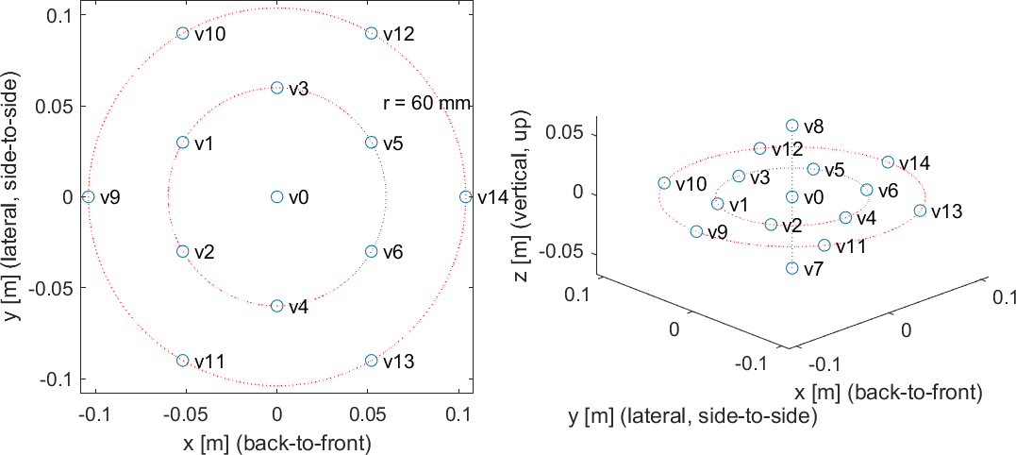

*Figure 1: Visualization of the view positions of the ClassroomVideo sequence*

The viewing space volume is a spheroid centered at source view v0 e.g. (0, 0, 0) meter position, with equatorial radius 104 mm and polar distance 60 mm:

$$\frac{x^{2}+y^{2}}{{\left(104 mm\right)}^{2}}+\frac{z^{2}}{{\left(60 mm\right)}^{2}}=1$$

**Museum**

The general characteristics of the Museum sequence are summarized in Table 8. The cameras are disposed on a spherical surface of 30 cm radius, and divergent in the direction of the sphere radius. Figure 2 provides the (X, Y, Z) coordinates and the spherical dimension, with an example using the 11th view. The metadata file comprising source and intermediate view positions is attachment A12 to this output document.

*Table 8: Characteristics of the Museum sequence*

|  |  |
| --- | --- |
| Category – Short name | CG - B |
| Input contribution | WG 11 M42349 |
| Length & frame rate | 300 frames (30 fps) |
| Number of source views | 24 |
| Source view resolution | 2048 × 2048 |
| Texture format | YUV 4:2:0 10 bits |
| Depth format | YUV 4:2:0 16 bits, normalized disparity in [0.5m, 25m] range |
| View FoV & mapping | 180° × 180° ERP |
| Global FoV | 360° × 180° |

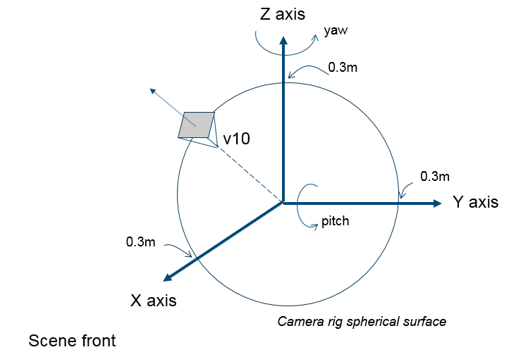

*Figure 2: Coordinate system as used by 3D Audio and OMAF, with view 10 of the Museum sequence superimposed*

The viewing space volume is a sphere centered at position [0, 0, 1.65] meter with a 300 mm radius:

$$\frac{x^{2}+y^{2}+{(z-1.65 m)}^{2}}{{\left(300 mm\right)}^{2}}=1$$

**Hijack**

The general characteristics of the Hijack sequence are summarized in Table 9. Figure 3 provides a visualization of the virtual camera rig in bias, top and front view respectively. The metadata file comprising source and intermediate view positions is in attachment of this output document.

*Table 9: Characteristics of the Hijack sequence*

|  |  |
| --- | --- |
| Category – Short name | CG - C |
| Input contribution | WG 11 M42349 |
| Length & frame rate | 300 frames (30 fps) |
| Number of source views | 10 |
| Source view resolution | 4096 × 2048 |
| Texture format | YUV 4:2:0 10 bits |
| Depth format | YUV 4:2:0 16 bits, normalized disparity in [0.5m, 25m] range |
| View FoV & mapping | 180° × 90° ERP |
| Global FoV | 180° × 90° |

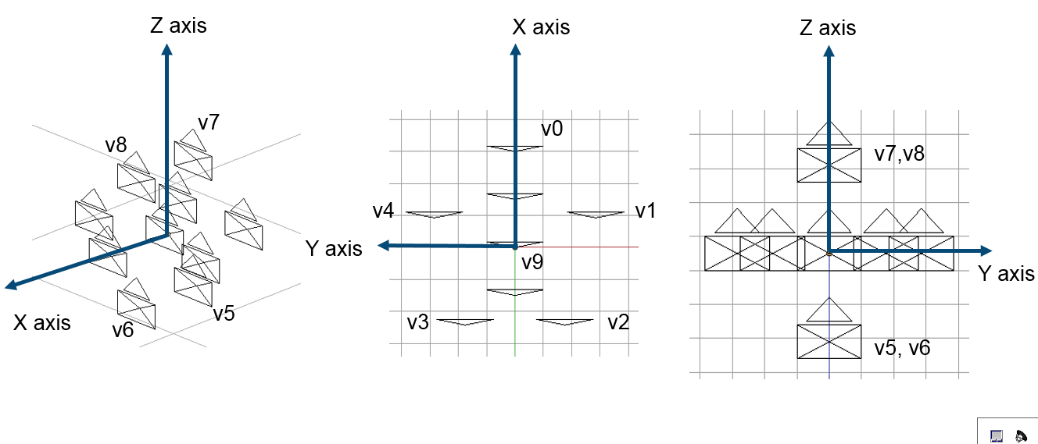

*Figure 3: Visualization of the view positions of the Hijack sequence*

The viewing space volume is a sphere centered at position [0, 0, 1.65] meter with a 300 mm radius:

$$\frac{x^{2}+y^{2}+{(z-1.65 m)}^{2}}{{\left(300 mm\right)}^{2}}=1$$

**Group**

The general characteristics of the Group sequence are summarized in Table 10 and source view positions illustrated in Figure 4.

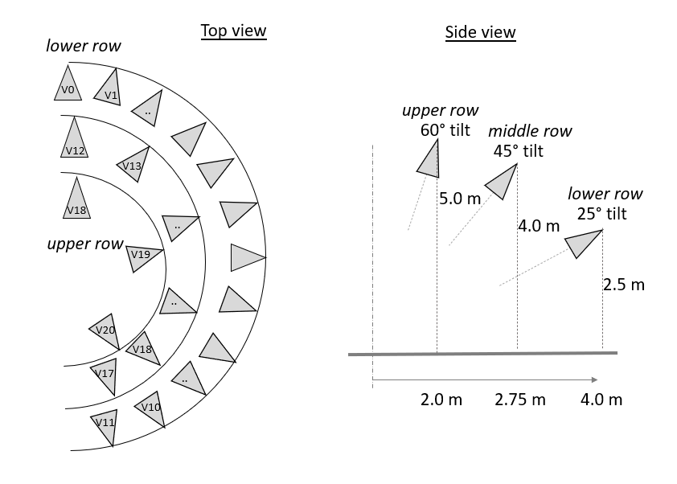

Figure 4: Visualization of the view positions of the Group sequence

The captured views form a partial dome of 21 views made of lower, middle and upper arc shape row, roughly span over 180° and looking inward to a central scene.

*Table 10: Characteristics of the Group sequence*

|  |  |
| --- | --- |
| Category - Name | CG - R |
| Input contribution | WG 11 M54731 |
| Length & frame rate | 99 frames (30 fps) |
| Number of source views | 21 |
| Source view resolution | 1920x1080 |
| Texture format | YUV 4:2:0 10 bits |
| Depth format | YUV 4:2:0 16 bits |
| View FoV & mapping | 75° × 48° Rectilinear |
| Camera spacing | 12 cameras span on #180° of arc radius 4.0m, height 2.5 m tilt 25°  6 cameras span on #180° of arc radius 2.75m, height 4.0 m tilt 45°  3 cameras span on #180° of arc radius 2.0m, height 5.0 m tilt 60° |
| zNear | 1.5 m |
| zFar | 25.0 m |

The viewing space volume is a flat volume which would be wrapped around this partial half dome.

**Fan**

**Warning: depth maps of Fan sequence have been update from CTC TMIV9 to CTC TMIV10.**

The general characteristics of the Fan sequence are summarized in Table 11. The rig is a planar rectangular rig of 5 by 3 cameras with a slight tilt downward.

*Table 11: Characteristics of the Fan sequence*

|  |  |
| --- | --- |
| Category - Name | CG - O |
| Input contribution | WG 11 M54732 |
| Length & frame rate | 97 frames (30 fps) |
| Number of source views | 15 |
| Source view resolution | 1920x1080 |
| Texture format | YUV 4:2:0 10 bits |
| Depth format | YUV 4:2:0 16 bits |
| View FoV & mapping | 50° horizontal Rectilinear |
| Camera spacing | 5 x 3 rectangular rig spaced by 10cm horizontally and vertically  1st row: v0 to v4  2nd row: v5 to v9  3rd row: v10 to v14 |
| zNear | 0.35 m |
| zFar | 12.5 m |

The viewing space volume is a spheroid encompassing the 15 cameras.

**ChessPieces**

The general characteristics of the ChessPieces sequence are exactly the same as Chess and summarized in Table 12. The notable differences between Chess and ChessPieces are:

* ChessPieces has an improved utilization of depth range, which is now adjusted per source view to the actual minimum and maximum,
* Additional inclusion of entity maps which annotate physical objects and is provided each input source view. The sequence contains roughly 60 separate indexed entities.

*Table 12: Characteristics of the ChessPieces sequence*

|  |  |
| --- | --- |
| Category - Name | CG - Q |
| Input contributions | WG 11 M54382 |
| Length & frame rate | 300 frames (30 fps) |
| Number of source views | 10 |
| Texture format | YUV 4:2:0 10-bits |
| Depth format | YUV 4:2:0 16-bits, normalized disparity in (0.1m, $500$ m) sub range |
| Source view resolution | 2048 × 2048 |
| View FoV & mapping | 180° × 180° ERP |
| Global FoV | 360° × 180° |

**Chess**

The general characteristics of the Chess sequence are summarized in Table 13. In total there are ten source cameras, laid out in a sphere-like arrangement as illustrated in Figure 5. One camera in the constellation captures the top of the scene and another the bottom. The remaining eight cameras are pointing outwards to capture the rest of the scene. The radius of the spherical camera constellation is 30 cm. This sequence also comes with a ground truth pose-trace viewport video.

*Table 13: Characteristics of the Chess sequence*

|  |  |
| --- | --- |
| Category – Short name | CG - N |
| Input contributions | WG 11 M50787 |
| Length & frame rate | 300 frames (30 fps) |
| Number of source views | 10 |
| Texture format | YUV 4:2:0 10-bits |
| Depth format | YUV 4:2:0 16-bits, normalized disparity in (0.1m, $500$ m) range |
| Source view resolution | 2048 × 2048 |
| View FoV & mapping | 180° × 180° ERP |
| Global FoV | 360° × 180° |

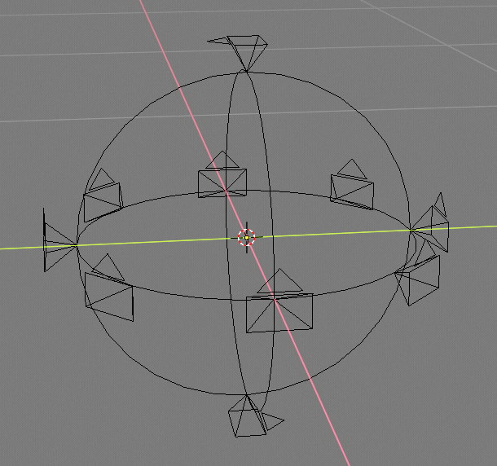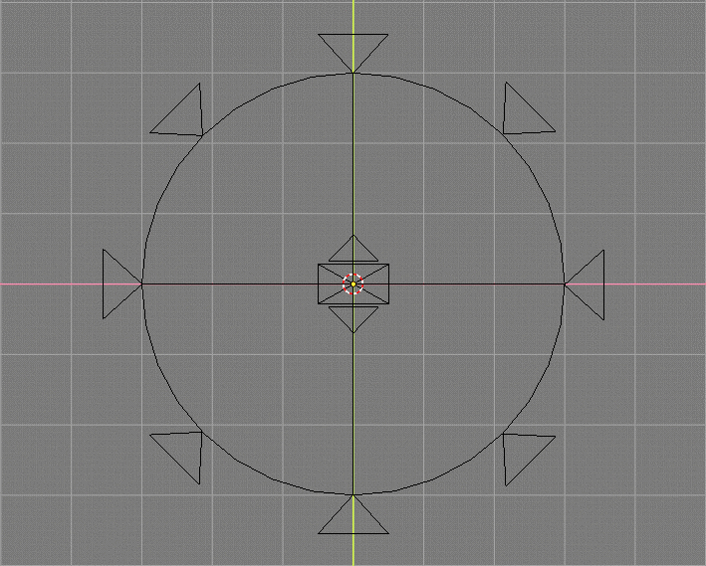

*Figure 5: visualization of the camera constellation for Chess*

The viewing space volume is a sphere centered at position [-0.5, -0.5, 1.0] meter with a 300 mm radius:

$$\frac{{(x+0.5m)}^{2}+({y+0.5m)}^{2}+{(z-1m)}^{2}}{{\left(300 mm\right)}^{2}}=1$$

**Kitchen**

The general characteristics of the Kitchen sequence are summarized in Table 14 and source view positions in Table 25. The captured views form a 5 × 5 planar array and are numbered v0-0 to v4-4 following left to right and top to bottom scan order.

*Table 14: Characteristics of the Kitchen sequence*

|  |  |
| --- | --- |
| Category – Short name | CG - J |
| Input contribution | WG 11 M43318 |
| Length & frame rate | 97 frames (30 fps) |
| Number of source views | 25 (5x5) |
| Source view resolution | 1920x1080 |
| Texture format | YUV 4:2:0 10 bits |
| Depth format | YUV 4:2:0 10 bits |
| View FoV & mapping | 53.1° × 31.4° Rectilinear |
| Lens | 32 mm |
| Camera spacing | 20cm x 20cm |
| zNear | 2.2 |
| zFar | 7.2 |

The viewing space volume is a spheroid centered at position [0, -0.4, 0.4] meter, covering a vertical square of side equal to 0.8m and developed in the forward axis by 0.35m max.

**Cadillac**

The general characteristics of the Cadillac sequence are summarized in Table 23. The rig is a planar rectangular rig of 5 by 3 cameras with a slight tilt upward.

*Table 23: Characteristics of the Cadillac sequence*

|  |  |
| --- | --- |
| Category - Name | CG - I |
| Input contribution | WG 11 M57186< |
| Length & frame rate | 100 frames (30 fps) |
| Number of source views | 15 |
| Source view resolution | 1920x1080 |
| Texture format | YUV 4:2:0 10 bits |
| Depth format | YUV 4:2:0 16 bits |
| View FoV & mapping | 66° horizontal Rectilinear |
| Camera spacing | 5 x 3 rectangular rig spaced by 20cm horizontally and vertically  1st row: v0 to v4  2nd row: v5 to v9  3rd row: v10 to v14 |
| zNear | 1.0 m |
| zFar | 14.0 m |

The viewing space volume is a spheroid encompassing the 15 cameras.

***Natural content with estimated depth***

**Painter**

The general characteristics of the Painter sequence are summarized in Table 15 and source view naming in Table 24 form a 4x4 planar array and are numbered v0-0 to v3-3 following left to right and top to bottom scan order, as shown in Table 16. The refined depths proposed in [m47445] are used.

*Table 16: Summary of the Painter sequence*

|  |  |
| --- | --- |
| Category – Short name | NC - D |
| Input contributions | WG 11 M40010, WG 11 M40011, WG 11 M43366 and WG 11 M47445. |
| Length & frame rate | 300 frames (30 fps) |
| Number of source views | 16 (4x4) |
| Source view resolution | 2048 × 1088 |
| Texture format | YUV 4:2:0 10 bits |
| Depth format | YUV 4:2:0 16 bits |

*Table 17: View numbering of the Painter camera array*

|  |  |  |  |
| --- | --- | --- | --- |
| v0-0 | v1-0 | v2-0 | v3-0 |
| v0-1 | v1-1 | v2-1 | v3-1 |
| v0-2 | v1-2 | v2-2 | v3-2 |
| v0-3 | v1-3 | v2-3 | v3-3 |

The viewing space volume is a spheroid centered at position [0, -0.35, -0.35] meter, covering a vertical square of side equal to 20cm and developed in the forward axis by 25cm max.

**Frog**

The general characteristics of the Frog sequence are summarized in Table 17 and source view positions in Table 26. The captured views form a 15x1 line and are numbered v0-0 to v14-0 following left to right scan order. The refined depths proposed in [m47445] are used; these depths do not exist for extreme view positions v0 and v14 and therefore only the views from v1 to v13 are used.

*Table 18: Characteristics of the Frog sequence*

|  |  |
| --- | --- |
| Category – Short name | NC - E |
| Input contribution | WG 11 M43748, WG 11 M44914 and WG 11 M47445 |
| Length & frame rate | 300 frames (30 fps) |
| Number of source views | 13 (13x1) |
| Source view resolution | 1920x1080 |
| Texture format | YUV 4:2:0 10 bits |
| Depth format | YUV 4:2:0 16 bits |
| View FoV & mapping | 63.65° × 38.47° Rectilinear |
| Lens | 2.16 mm |
| Camera spacing | 3.675 cm |
| zNear | 0.3 |
| zFar | 1.62 |

The viewing space volume is a rectangle centered at position [0, 0, 0] meter with a 15cm width, 44.1cm length, and no z component.

$$rect\left(\frac{x-7.5cm}{15 cm},\frac{y}{44.1cm},0\right)$$

**Fencing**

The general characteristics of the Fencing sequence are summarized in *Table 18* and source view positions in Table 27. The captured views form a 10x1 linear arc and are numbered v0-0 to v9-0 following left to right scan order.

Warning: Fencing textures have changed from WG 11 N 19484 to WG 11 N 19679.

Warning: Fencing depth maps have changed from WG 11 N 19484 to WG 11 N 19679.

*Table 19: Characteristics of the Fencing sequence*

|  |  |
| --- | --- |
| Category – Short name | NC - L |
| Input contribution | WG 11 M38247 |
| Length & frame rate | 250 frames (25 fps) |
| Number of source views | 10 |
| Source view resolution | 1920x1080 |
| Texture format | YUV 4:2:0 10 bits |
| Depth format | YUV 4:2:0 16 bits |
| View FoV & mapping | 63° × 48° |
| Lens | 4.5 mm |
| Camera spacing | 5 stereopairs (baseline: 22 cm) placed on arc (radius: 4 m),  angle between neighboring stereopairs: 15 degrees,  total angle of the system: 60 degrees |
| zNear | 3.5 |
| zFar | 7.0 |

**Street**

The general characteristics of the Street sequence are summarized in Table 19. The captured views form a 9x1 line and are numbered v0 to v8 following left to right scan order.

*Table 20: Characteristics of the Street sequence*

|  |  |
| --- | --- |
| Category – Short name | NC - U |
| Input contribution | WG 11 M51598 |
| Length & frame rate | 250 frames (25 fps) |
| Number of source views | 9 (9x1) |
| Source view resolution | 1920x1088 |
| Texture format | YUV 4:2:0 10 bits |
| Depth format | YUV 4:2:0 16 bits |
| View FoV & mapping | 63° × 48° |
| Lens | 4.5 mm |
| Camera spacing | 13.75 cm |
| zNear | 34.5064 |
| zFar | 2760.511 |

**Carpark**

The general characteristics of the Carpark sequence are summarized in Table 20. The captured views form a 9x1 line and are numbered v0 to v8 following left to right scan order.

*Table 21: Characteristics of the Carpark sequence*

|  |  |
| --- | --- |
| Category – Short name | NC - P |
| Input contribution | WG 11 M51598 |
| Length & frame rate | 250 frames (25 fps) |
| Number of source views | 9 (9x1) |
| Source view resolution | 1920x1088 |
| Texture format | YUV 4:2:0 10 bits |
| Depth format | YUV 4:2:0 16 bits |
| View FoV & mapping | 63° × 48° |
| Lens | 4.5 mm |
| Camera spacing | 13.75 cm |
| zNear | 34.5064 |
| zFar | 2760.511 |

**Hall**

The general characteristics of the Hall sequence are summarized in Table 21. The captured views form a 9x1 line and are numbered v0 to v8 following left to right scan order. Camera rig in the Hall sequence was moving along the scene, but camera parameters remained the same for all frames.

Warning: Hall textures have changed from WG 11 N 19484 to WG 11 N 19679.

*Table 22: Characteristics of the Hall sequence*

|  |  |
| --- | --- |
| Category - Name | NC - T |
| Input contribution | WG 11 M51598 |
| Length & frame rate | 500 frames (25 fps) |
| Number of source views | 9 (9x1) |
| Source view resolution | 1920x1088 |
| Texture format | YUV 4:2:0 10 bits |
| Depth format | YUV 4:2:0 16 bits |
| View FoV & mapping | 63° × 48° |
| Lens | 4.5 mm |
| Camera spacing | 13.75 cm |
| zNear | 18.5064 |
| zFar | 2760.511 |

The viewing space volume is an arc centered at the origin with a 2.34m width, 6.89m length, and no z component.

**Mirror**

The general characteristics of the Mirror sequence are summarized in Table 22. The rig is a planar rectangular rig of 5 by 3 cameras with a slight tilt downward.

*Table 23: Characteristics of the Mirror sequence*

|  |  |
| --- | --- |
| Category - Name | CG - I |
| Input contribution | WG 11 M55710 |
| Length & frame rate | 100 frames (30 fps) |
| Number of source views | 15 |
| Source view resolution | 1920x1080 |
| Texture format | YUV 4:2:0 10 bits |
| Depth format | YUV 4:2:0 16 bits |
| View FoV & mapping | 70° horizontal Rectilinear |
| Camera spacing | 5 x 3 rectangular rig spaced by 20cm horizontally and vertically  1st row: v0 to v4  2nd row: v5 to v9  3rd row: v10 to v14 |
| zNear | 1.5 m |
| zFar | 8.0 m |

The viewing space volume is a spheroid encompassing the 15 cameras.